**Golden Apple Juice**

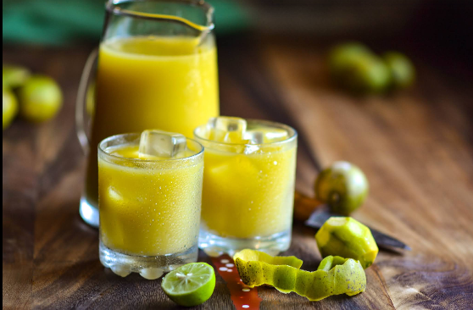

**INGREDIENTS**

5 Large June plums

5 cups of water

A Stick of Ginger (about the length of your thumb)

Sugar for sweetening

**METHOD**

1. Wash the June plums well to remove any soil or debris. Remove the flesh from the seed and dice.
2. Wash, peel and dice the ginger.
3. Add the June plum, ginger and water into a blender and blend until smooth. Separate into 2 batches if you need to.
4. Strain into a large jug using either cheesecloth, nut milk bag, or a fine strainer/sieve. find out how you can purchase a nut milk bag below, if needed)
5. Sweeten to your preferred liking, and refrigerate.
6. Serve over ice, and enjoy!
7. I’ve noticed that juice made from green June Plums has a distinct taste to that made from ripe (yellow) June Plums. I like both, and find it hard to choose a favourite!
8. If you’re making drink with the ripe June Plums, you may wish to add about a teaspoon of lemon juice, which gives it a nice kick!

After coconut water, this has got to be my most favourite juice drink! The flavour is unique, fresh, sweet, and tangy all at the same time.